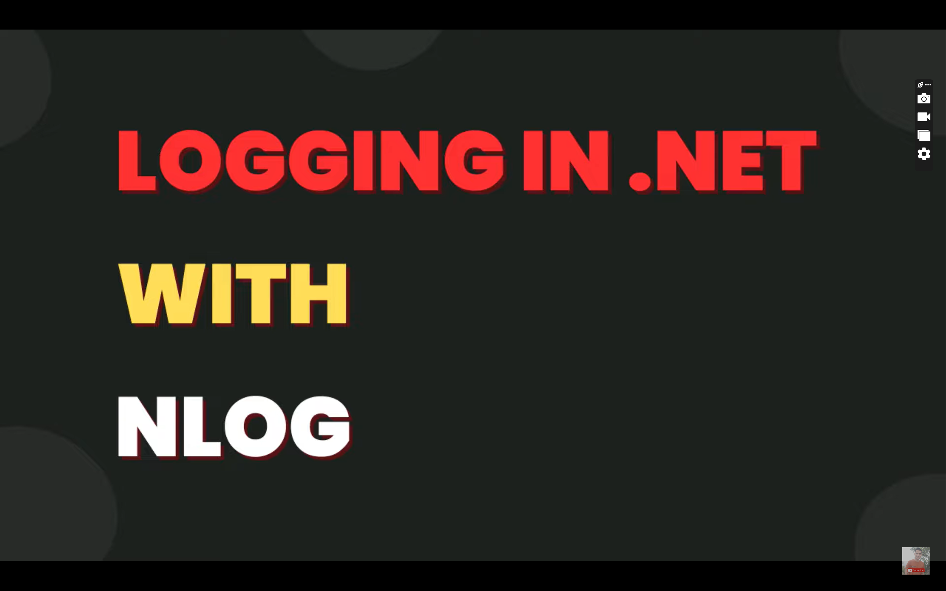

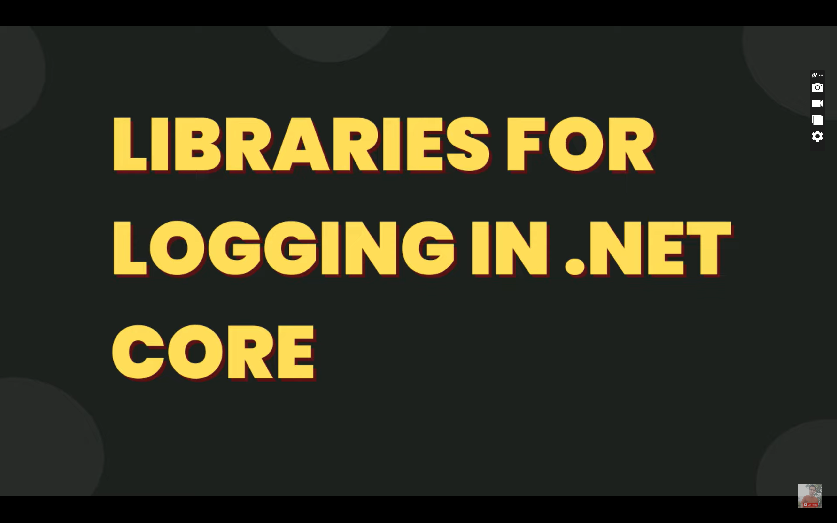

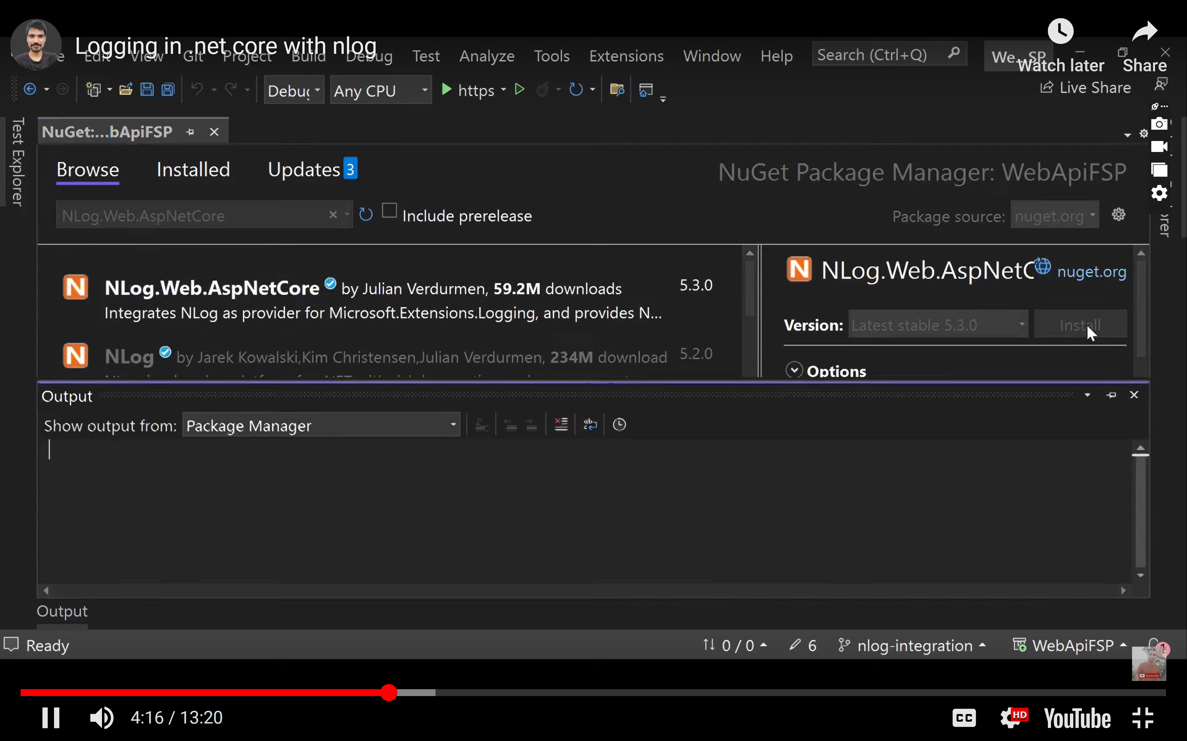

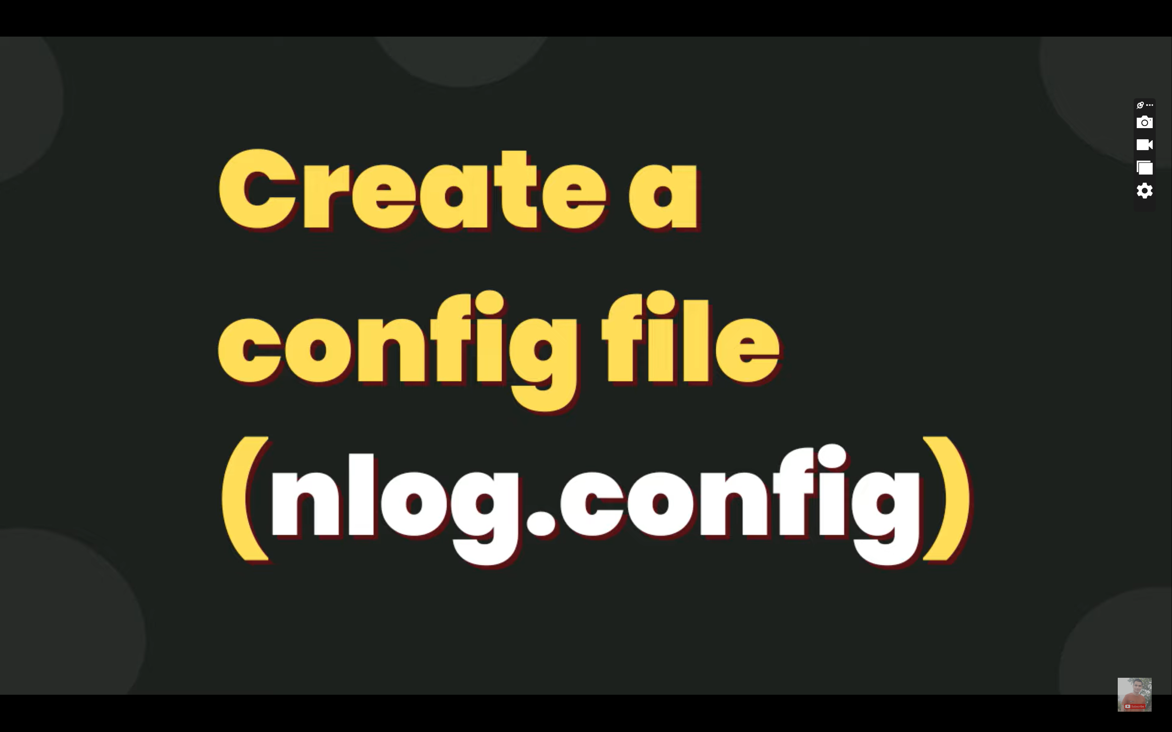

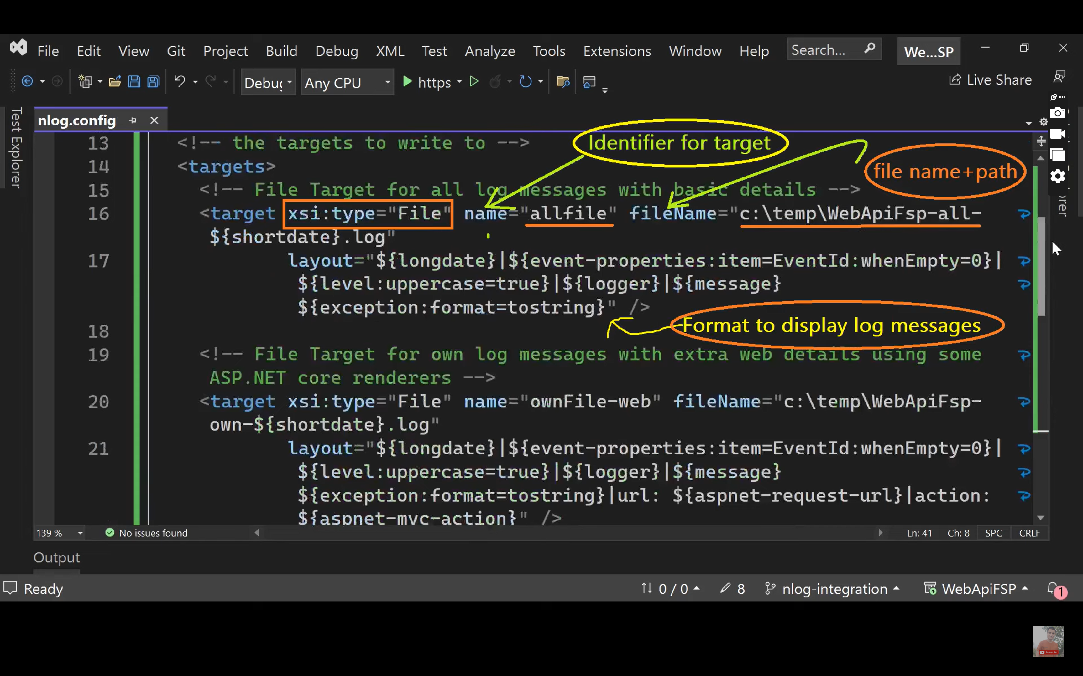

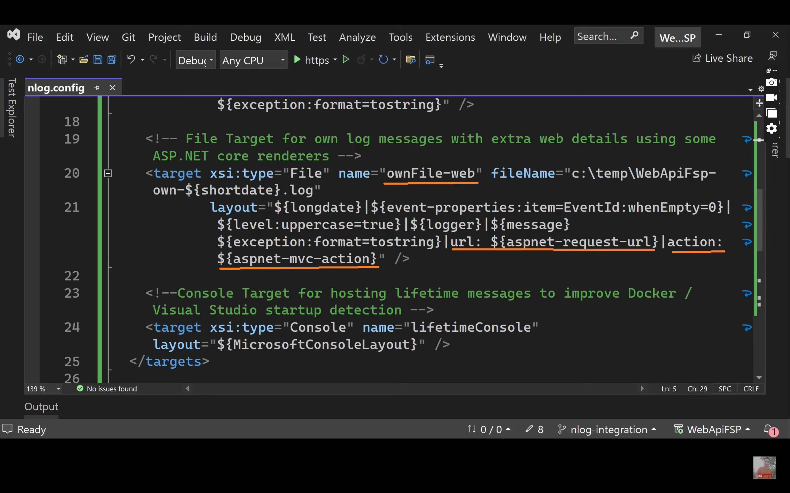

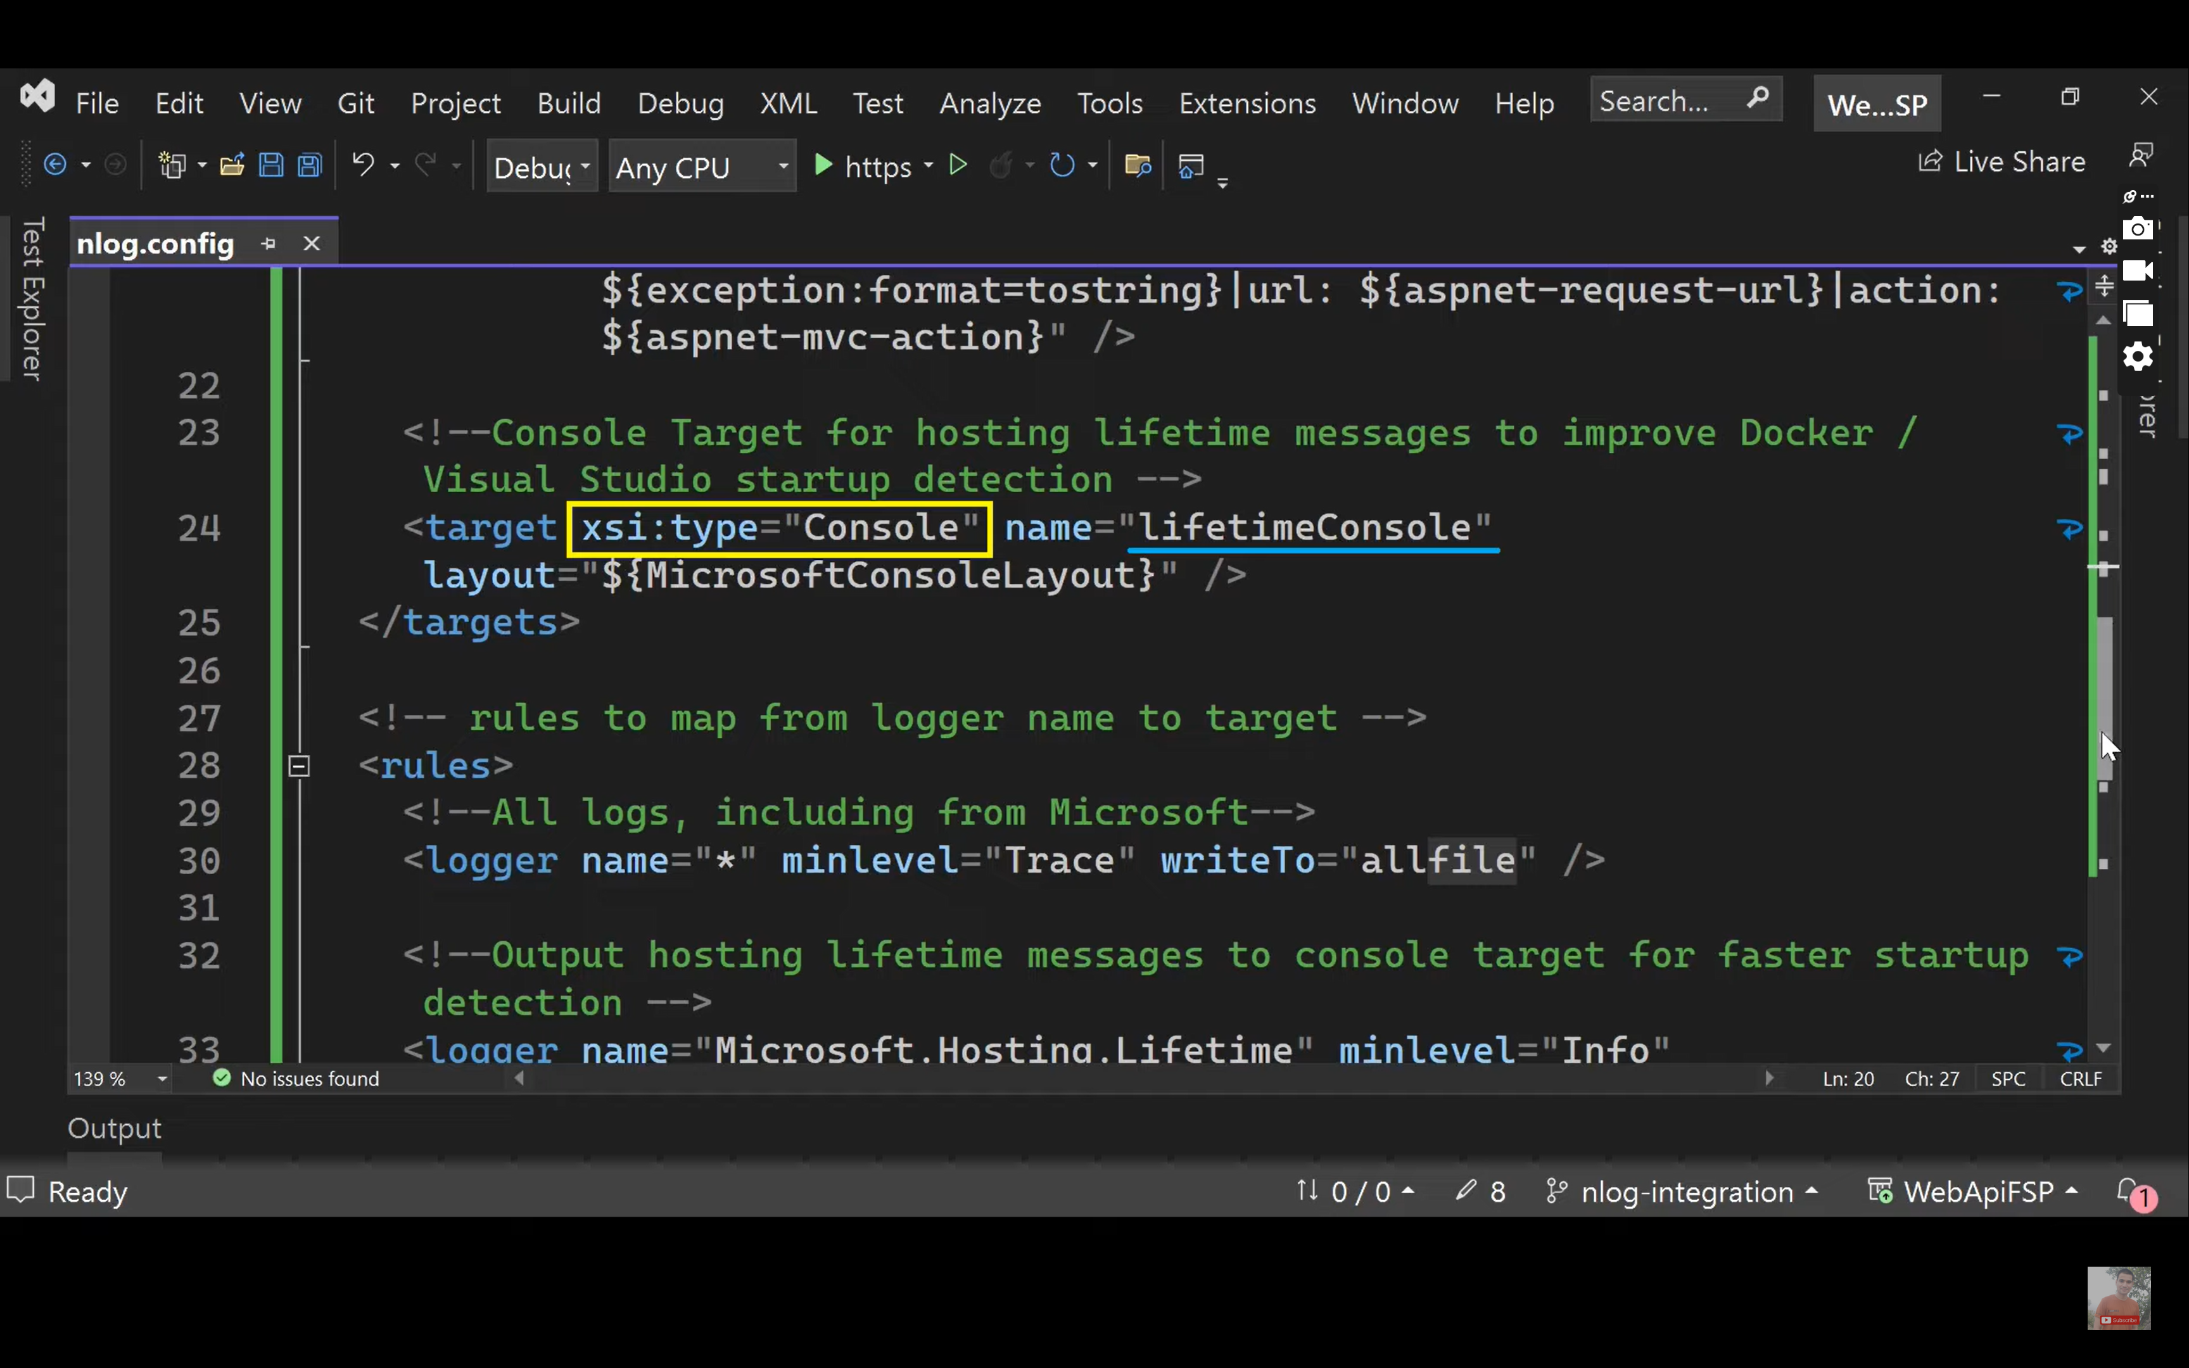

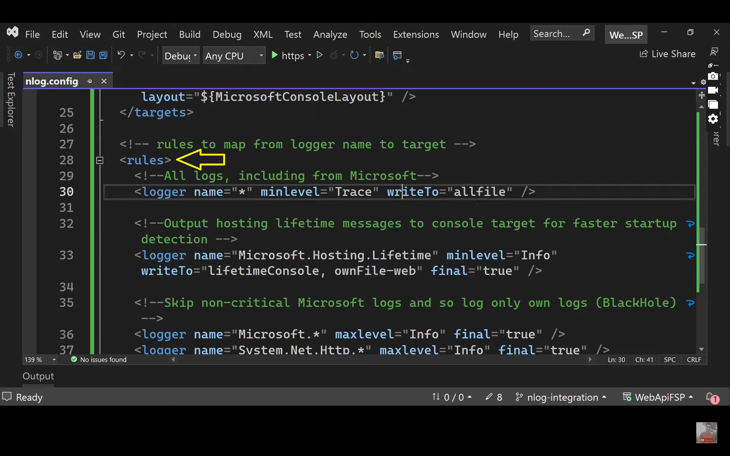

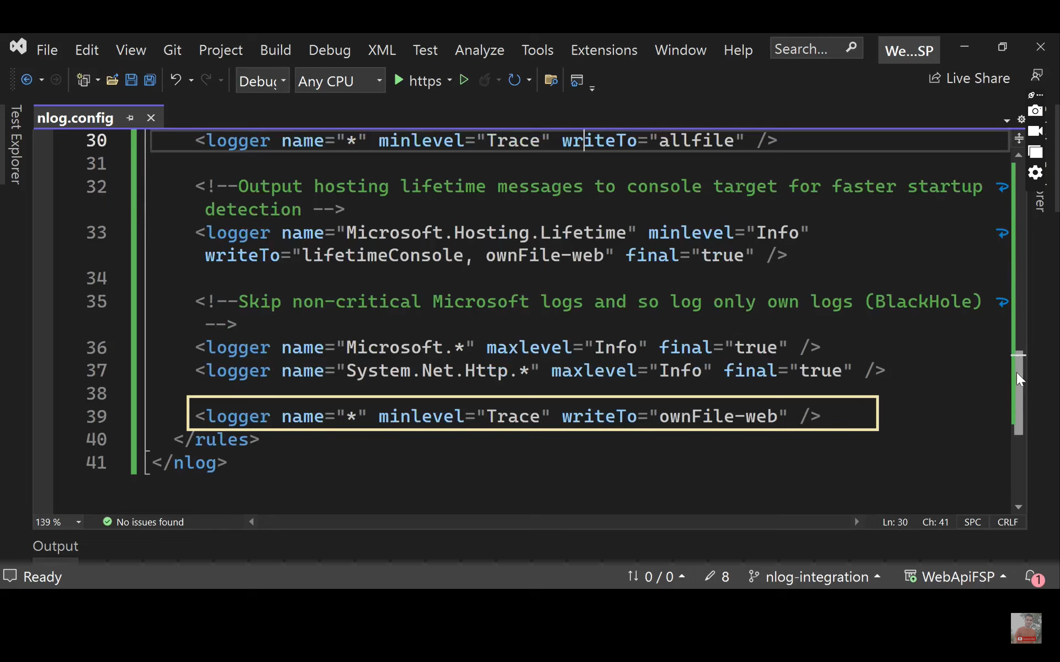

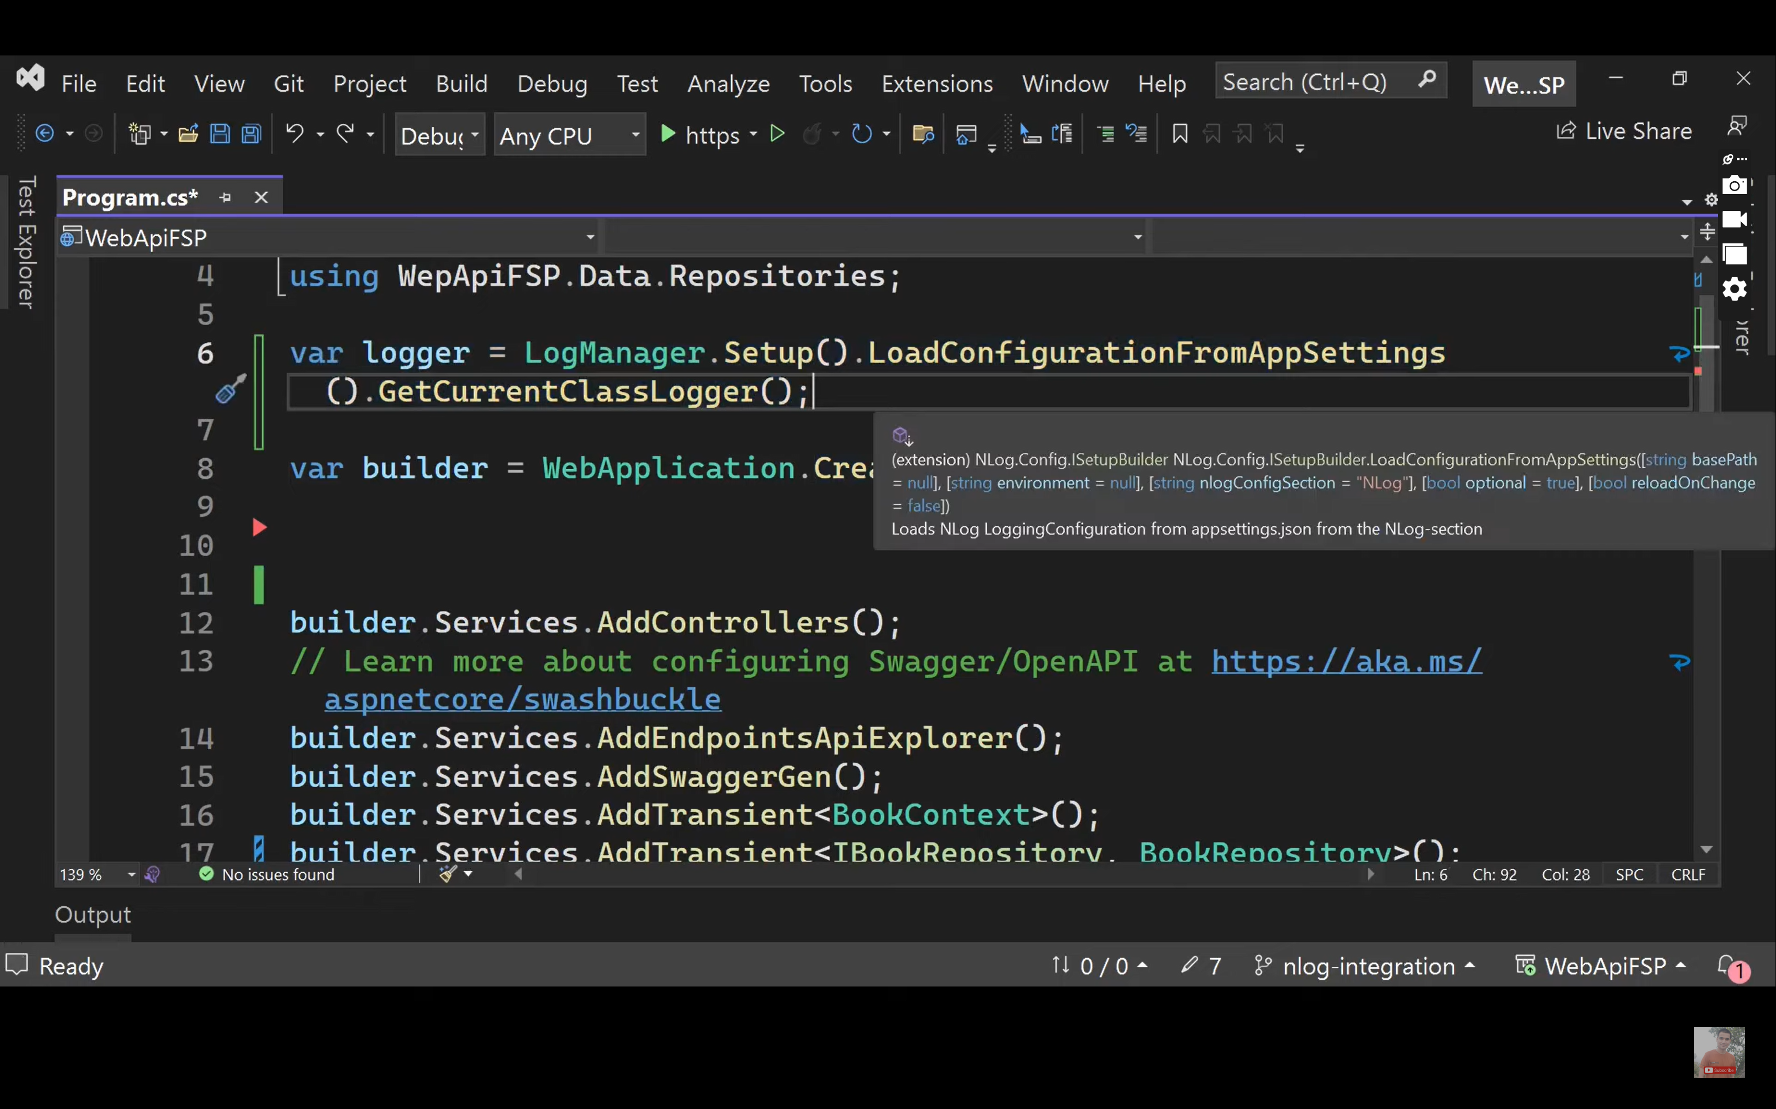

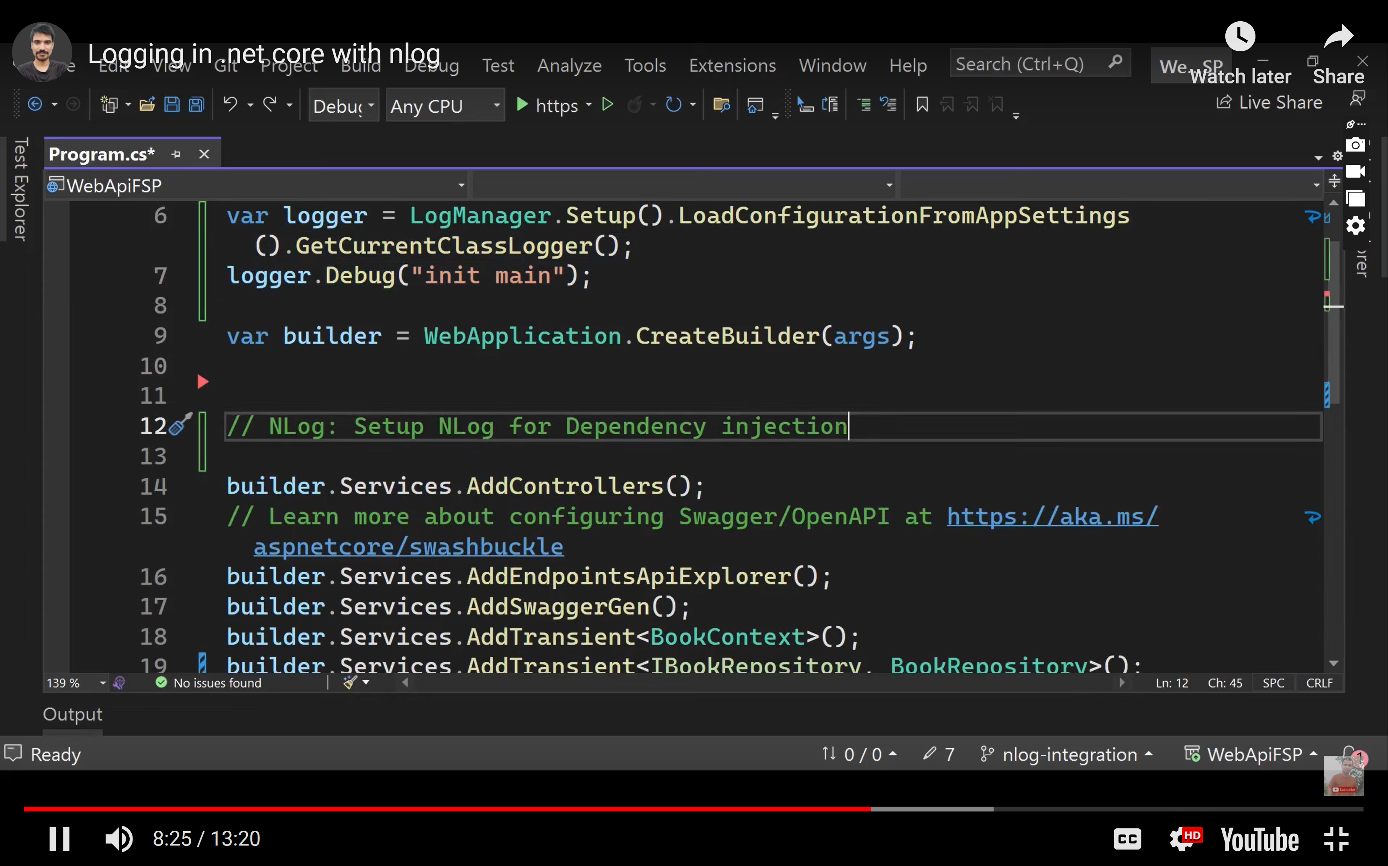

<?xml version="1.0" encoding="utf-8" ?>

<nlog xmlns="http://www.nlog-project.org/schemas/NLog.xsd"

xmlns:xsi="http://www.w3.org/2001/XMLSchema-instance"

autoReload="true"

internalLogLevel="Trace"

internalLogFile="C:/Users/anami/Amity/Day2/logs/${shortdate}_logfile.txt">

<targets>

<target name="logfile" xsi:type="File"

fileName="C:/Users/anami/Amity/Day1/logs/${shortdate}_logfile.txt"

layout="${longdate} ${level:uppercase=true} ${message}"/>

</targets>

<rules>

<logger name="*" minlevel="Info" writeTo="logfile" />

</rules>

</nlog>

using Microsoft.AspNetCore.Http;

using Microsoft.AspNetCore.Mvc;

using Microsoft.Extensions.Logging;

using NLog;

namespace CourseApi.Controllers

{

[Route("api/[controller]")]

[ApiController]

public class CourseController : ControllerBase

{

private static Logger logger = LogManager.GetLogger("CourseController");

//ILogger<CourseController> _logger;

public CourseController()

{

}

[HttpGet]

public List<string> Get()

{

List<string> list = new List<string>();

if (list.Count == 0)

{

logger.Warn("List is e,p;lty");

//list = new List<string>()

; return list;

}

else

{

logger.Info("info");

logger.Error("crtical");

//_logger.LogError("ERror");

return new List<string>()

{

"abc", "def","zyz"

};

}

}

}

}

<?xml version="1.0" encoding="utf-8" ?>

<nlog xmlns="http://www.nlog-project.org/schemas/NLog.xsd"

xmlns:xsi="http://www.w3.org/2001/XMLSchema-instance"

autoReload="true"

internalLogLevel="Info"

internalLogFile="c:\temp\WebApiFsp-Internal-Logs.txt">

<!-- enable asp.net core layout renderers -->

<extensions>

<add assembly="NLog.Web.AspNetCore"/>

</extensions>

<!-- the targets to write to -->

<targets>

<!-- File Target for all log messages with basic details -->

<target xsi:type="File" name="allfile" fileName="c:\temp\WebApiFsp-all-${shortdate}.log"

layout="${longdate}|${event-properties:item=EventId:whenEmpty=0}|${level:uppercase=true}|${logger}|${message} ${exception:format=tostring}" />

<!-- File Target for own log messages with extra web details using some ASP.NET core renderers -->

<!--<target xsi:type="File" name="ownFile-web" fileName="c:\temp\WebApiFsp-own-${shortdate}.log"

layout="${longdate}|${event-properties:item=EventId:whenEmpty=0}|${level:uppercase=true}|${logger}|${message} ${exception:format=tostring}|url: ${aspnet-request-url}|action: ${aspnet-mvc-action}" />-->

<target xsi:type="File" name="ownFile-web" fileName="c:\temp\WebApiFsp-own-${shortdate}.log">

<layout xsi:type="JsonLayout" includeEventProperties="true">

<attribute name="time" layout="${longdate}" />

<attribute name="event" layout="${event-properties:item=EventId:whenEmpty=0}"/>

<attribute name="level" layout="${level:upperCase=true}"/>

<attribute name="logger" layout="${logger}"/>

<attribute name="message" layout="${message}" />

<attribute name="exception" layout="${exception:format=tostring}"/>

<attribute name="url" layout="${aspnet-request-url}" />

<attribute name="action" layout="${aspnet-mvc-action}" />

</layout>

</target>

<!--Console Target for hosting lifetime messages to improve Docker / Visual Studio startup detection -->

<target xsi:type="Console" name="lifetimeConsole" layout="${MicrosoftConsoleLayout}" />

</targets>

<!-- rules to map from logger name to target -->

<rules>

<!--All logs, including from Microsoft-->

<logger name="*" minlevel="Trace" writeTo="allfile" />

<!--Output hosting lifetime messages to console target for faster startup detection -->

<logger name="Microsoft.Hosting.Lifetime" minlevel="Info" writeTo="lifetimeConsole, ownFile-web" final="true" />

<!--Skip non-critical Microsoft logs and so log only own logs (BlackHole) -->

<logger name="Microsoft.*" maxlevel="Info" final="true" />

<logger name="System.Net.Http.*" maxlevel="Info" final="true" />

<logger name="*" minlevel="Trace" writeTo="ownFile-web" />

</rules>

</nlog>

using CourseApi.Autehntication;

using CourseApi.Models;

using GlobalExceptionHandling.Utility;

//using log4net;

// using log4net.Config;

using Microsoft.AspNetCore.Authentication;

using Microsoft.AspNetCore.Authentication.JwtBearer;

using Microsoft.AspNetCore.Http.Json;

using Microsoft.IdentityModel.Tokens;

using Microsoft.OpenApi.Models;

using NLog;

using NLog.Web;

using Swashbuckle.AspNetCore.SwaggerGen;

using System.Reflection;

using System.Text;

using System.Text.Json;

//using Log4NetSample.LogUtility;

namespace CourseApi

{

public class Program

{

public static void Main(string[] args)

{

var builder = WebApplication.CreateBuilder(args);

var logger = LogManager.Setup().LoadConfigurationFromAppSettings()

.GetCurrentClassLogger();

logger.Info("Insie Main");

// Add services to the container.

try

{

builder.Logging.ClearProviders();

builder.Host.UseNLog();

// JWT Authentication

builder.Services.AddDbContext<DBContext>();

builder.Services.AddScoped<JwtAuthenticationManager>();

builder.Services.AddControllers(options => options.ReturnHttpNotAcceptable = true);

builder.Services.AddAuthentication(x =>

{

x.DefaultAuthenticateScheme = JwtBearerDefaults.AuthenticationScheme;

x.DefaultChallengeScheme = JwtBearerDefaults.AuthenticationScheme;

x.DefaultScheme = JwtBearerDefaults.AuthenticationScheme;

}).

AddJwtBearer(options =>

{

options.TokenValidationParameters = new TokenValidationParameters

{

ValidateIssuer = true,

ValidateAudience = true,

ValidateLifetime = true,

ValidateIssuerSigningKey = true,

ValidIssuer = builder.Configuration["Jwt:Issuer"],

ValidAudience = builder.Configuration["Jwt:Audience"],

IssuerSigningKey = new SymmetricSecurityKey(Encoding.UTF8.GetBytes(builder.Configuration["Jwt:Key"]))

};

});

builder.Services.AddSwaggerGen(options =>

{

options.AddSecurityDefinition(name: "Bearer", securityScheme: new OpenApiSecurityScheme()

{

Name = "Authorization",

Type = SecuritySchemeType.ApiKey,

Scheme = "Bearer",

BearerFormat = "JWT",

In = ParameterLocation.Header,

Description = "Sec"

});

options.AddSecurityRequirement(securityRequirement: new OpenApiSecurityRequirement

{

{

new OpenApiSecurityScheme

{

Reference=new OpenApiReference{

Type=ReferenceType.SecurityScheme,

Id="Bearer"

}

},

new String[]{ }

}

});

});

//var logRepository = LogManager.GetRepository(Assembly.GetEntryAssembly());

//XmlConfigurator.Configure(logRepository, new FileInfo("log4net.config"));

builder.Services.AddControllers();

builder.Services.AddSwaggerGen();

builder.Services.AddControllers()

.AddXmlSerializerFormatters();

builder.Services.Configure<JsonOptions>(options =>

{

options.SerializerOptions.IncludeFields = false;

});

var options = new JsonSerializerOptions(JsonSerializerDefaults.Web);

var app = builder.Build();

//var _log4net = log4net.LogManager.GetLogger(typeof(Program));

//_log4net.Info("Hello Logging World");

// Configure the HTTP request pipeline.

app.UseAuthentication();

app.UseAuthorization();

//app.UseMiddleware(typeof(GlobalErrorHandlingMiddleware));

app.UseSwagger();

app.UseSwaggerUI();

app.MapControllers();

app.Run();

}

catch(Exception ex)

{

logger.Error(ex.Message);

}

finally

{

LogManager.Shutdown(); }

}

}

}

using Microsoft.AspNetCore.Http;

using Microsoft.AspNetCore.Mvc;

using Microsoft.Extensions.Logging;

using NLog;

namespace CourseApi.Controllers

{

[Route("api/[controller]")]

[ApiController]

public class CourseController : ControllerBase

{

//private static Logger logger = LogManager.GetLogger("CourseController");

private ILogger<CourseController> _logger;

//ILogger<CourseController> _logger;

public CourseController(ILogger<CourseController> logger)

{

_logger = logger;

}

[HttpGet]

public List<string> Get()

{

List<string> list = new List<string>();

if (list.Count == 0)

{

_logger.LogError("List is e,p;lty");

//list = new List<string>()

; return list;

}

else

{

_logger.LogInformation("info");

_logger.LogCritical("crtical");

//_logger.LogError("ERror");

return new List<string>()

{

"abc", "def","zyz"

};

}

}

}

}